# DETECTION OF POST-TRAUMATIC STRESS DISORDER USING DEEP LEARNING BY IDRIS SALAU GATA

# 21D/47CS/2017

# CHAPTER 1: INTRODUCTION

## 1.1 Background to study

Post-traumatic stress disorder (PTSD) is a debilitating mental health condition that can develop after exposure to a traumatic event, whether witnessing the event in-person, indirectly learning that a traumatic event occurred to a loved one, or through repeated exposure to aversive details of said events **(Benjet et al., 2016).** Traditional diagnosis relies on clinical interviews and self-reported symptoms. These methods can be subjective, time-consuming, and susceptible to bias. Deep learning (DL), a subfield of artificial intelligence, offers a promising approach for detecting PTSD more objectively and efficiently. By leveraging the power of complex algorithms and vast amounts of data, DL has the potential to revolutionize the way we diagnose and manage PTSD. **(Banerjee et al., 2019)**

Recent studies have explored the potential of DL in PTSD detection using various data modalities. One such study by (**Schultebrauck et al., 2020)** investigated the use of a deep neural network to analyze a combination of facial expressions, speech patterns, and language content extracted from clinical interviews **(Schultebrauck et al., 2020)** This multimodal approach aimed to capture the multifaceted nature of PTSD, which often manifests in emotional, behavioral, and cognitive symptoms. The study's findings were encouraging, with the DL model achieving an Area Under the Curve (AUC) of 0.90. This indicates good discriminatory power in classifying individuals with PTSD from those without. Similarly, (**Yang et al., 2021)** employed DL on brain functional magnetic resonance imaging (fMRI) data to differentiate between PTSD and healthy controls (**Yang et al., 2021)**, Their research delved deeper into the neurological underpinnings of PTSD. By identifying specific brain regions that contribute most to the DL model's performance, the study offered valuable insights into the neural correlates of the disorder. This knowledge can inform the development of targeted therapies and interventions. The concept of machine learning and deep learning has been around for a long time. However, in recent years, these technologies have been revolutionized with the availability of big data and advancements in computing power. Machine learning and deep learning have become increasingly popular in various industries, including healthcare, finance, retail, and more **(Sharifani & Amini, 2023).**

The potential benefits of DL for PTSD detection are numerous. Machine learning techniques, including deep learning, have been shown to be effective in identifying PTSD when using multi-dimensional data sources (**Thew et al., 2024)** This offers a significant advantage over traditional methods that often rely on a single data type, such as self-reported symptom checklists. With the advent of deep learning (DL) methods, a variety of neural network approaches have been applied for fMRI classification, including autoencoders **(Patel et al., 2016),** Additionally, DL models can potentially analyze data faster and more objectively than human clinicians. This could lead to earlier diagnoses and interventions, which are crucial for preventing long-term complications associated with PTSD. Early intervention can improve treatment outcomes and quality of life for individuals suffering from the disorder.

However, challenges remain in the development and implementation of DL models for PTSD detection. While studies like those mentioned above have shown promising results, larger and more diverse datasets are needed to ensure the generalizability of these models **(Wu et al., 2023).** Currently available datasets may not adequately represent the full spectrum of PTSD presentations across different demographics and cultures. This can lead to biases in the algorithms, potentially impacting their accuracy and effectiveness in real-world settings. Furthermore, ethical considerations regarding data privacy and the potential for bias in algorithms need to be addressed. Robust data security measures and ongoing monitoring are essential to ensure patient privacy is protected. Additionally, researchers must be vigilant in identifying and mitigating potential biases within the algorithms themselves, such as those that could arise from skewed training data.

In conclusion, deep learning presents a significant opportunity for improving PTSD detection. By analyzing diverse data sources, DL models offer the potential for earlier diagnoses, more comprehensive assessments, and ultimately, more effective interventions. Continued research is necessary to refine these models, address ethical concerns, and ensure their generalizability across diverse populations. With careful development and implementation, deep learning has the potential to transform the diagnosis and management of PTSD, paving the way for a future where individuals receive the support they need to heal and thrive.

## 1.2 Statement of the problem

The primary problem to be solved is the underdiagnosis and delayed diagnosis of post-traumatic stress disorder (PTSD) due to the subjective nature and variability of current diagnostic methods, which rely heavily on self-reported symptoms and clinical interviews **(Greene et al., 2016).** The symptoms of PTSD may overlap with other disorders, making it difficult to establish a causal link **(Wu et al., 2023).**

## 1.3 Aim and Objectives

**Aim:**

To develop a deep learning tool that can be leveraged for the early detection of PTSD potentially improving treatment outcomes for individuals affected by this condition.

**Objectives:**

1. **Early and accurate diagnosis:** Using deep learning for PTSD detection can result in a timely diagnosis of the disorder. This timely intervention can improve patient outcomes by reducing symptom severity and preventing additional health issues. Deep learning enhances diagnostic accuracy by identifying patterns that traditional methods may miss, ensuring patients receive appropriate treatment promptly.
2. **Reduction in health personnel workload:** One issue that might result in a wrong diagnosis is that medical personnels might grow weary, therefore, giving inaccurate diagnosis to patients. The proposed software will be able to work through that since softwares do not get tired.
3. **Remote and point-of-care diagnosis:** The proposed software aims to provide remote access for individuals who are either geographically distant or unable to afford a proper health checkup.

## 1.4 Scope of study

The scope of this study encompasses the development and evaluation of a machine learning-based approach for the early detection of post traumatic stress disorder from Pre-recorded videos or live videos, with the aim of simplifying and expediting the diagnostic process compared to conventional methods.

## 1.5 Significance/justification of the study

The implementation of a deep learning system for PTSD detection has the potential to improve patient outcomes, prevent unforeseen complications, and optimize healthcare resource allocation, especially in underserved communities. Overall, the study's findings could significantly enhance PTSD management efforts and improve public health worldwide.

## 1.6 Definition of terms

1. **Post-Traumatic Stress Disorder (PTSD)**: A mental health condition triggered by experiencing or witnessing a traumatic event, characterized by symptoms such as flashbacks, severe anxiety, and uncontrollable thoughts about the event.
2. **Deep learning**: A subset of machine learning involving neural networks with many layers that can automatically learn and extract complex patterns from large datasets.
3. **Artificial intelligence (AI)**: The simulation of human intelligence processes by machines, especially computer systems, which includes learning, reasoning, and self-correction.
4. **Neural networks**: Computing systems inspired by the human brain's neural networks, consisting of interconnected nodes (neurons) that process data in layers to recognize patterns and solve complex problems.
5. **Recurrent neural networks (RNNs)**: A type of neural network particularly effective for sequential data because it can use its internal memory to process sequences of inputs, making it suitable for tasks like time series prediction and natural language processing.
6. **Diagnosis**: The process of identifying a disease or condition from its signs and symptoms through examination and testing
7. **Early detection**: The identification of a disease or condition at an initial stage, which can lead to more effective treatment and better outcomes.
8. **Accuracy**: The degree to which the result of a measurement or calculation conforms to the correct value or a standard.
9. **Sensitivity**: The ability of a test or model to correctly identify true positives, or the proportion of actual positives that are correctly identified by the test.
10. **Specificity**: The ability of a test or model to correctly identify true negatives, or the proportion of actual negatives that are correctly identified by the test.
11. **Neuroimaging**: The use of various techniques to either directly or indirectly image the structure, function, or pharmacology of the nervous system.
12. **Functional MRI (fMRI)**: A neuroimaging procedure that measures brain activity by detecting changes in blood flow, used to observe brain function.
13. **Electroencephalography (EEG)**: A monitoring method to record electrical activity of the brain, often used to diagnose conditions affecting brain function.
14. **Psychophysiological data**: Data that reflects the relationship between psychological processes and physiological responses, such as heart rate, skin conductance, and brain activity.
15. **Clinical assessment**: A systematic evaluation of a patient's health, including physical examination, medical history, and diagnostic testing, to diagnose and plan treatment.
16. **Symptom analysis**: The examination and interpretation of the signs and symptoms reported by a patient to identify the underlying condition or disease.
17. **Machine learning**: A branch of AI that involves the use of algorithms and statistical models to enable computers to improve their performance on a task through experience.
18. **Predictive model**: A mathematical model used to predict future outcomes based on historical data, often using machine learning techniques.
19. **Healthcare**: The organized provision of medical care to individuals or communities, including prevention, diagnosis, treatment, and management of illness.
20. **Mental health**: A state of well-being in which an individual realizes their abilities, can cope with normal stresses of life, can work productively, and is able to contribute to their community.

# Chapter Two - Literature Review

2.1 Related concepts to your work

### 2.1.1 Automated Diagnosis

The use of computer algorithms to identify diseases or conditions without human intervention. Deep learning models are trained to recognize patterns indicative of PTSD from various data sources. (Miotto et al., 2016)

### 2.1.2 Feature extraction

The process of selecting and transforming relevant data characteristics from raw data for use in a model. In PTSD detection, features might include specific brain activity patterns or text markers in clinical notes. (Zhang et al., 2017)

### 2.1.3 Neuroimaging Biomarkers

Biological markers obtained through neuroimaging techniques that indicate the presence or severity of PTSD. Biomarkers help in understanding the neural mechanisms underlying PTSD. (Rauch et al., 2006)

### 2.1.4 Natural Language Processing

A field of AI that focuses on the interaction between computers and humans through natural language. NLP can be used to analyze text data from patient records to identify PTSD symptoms. (Shickel et al., 2018)

### 2.1.5 Transfer Learning

A machine learning technique where a model developed for a particular task is reused as the starting point for a model on a different but related task. This is useful in PTSD detection when data is limited. (Pan et al., 2010)

### 2.1.6 Cross-Validation

A technique for evaluating how the results of a model will generalize to an independent dataset. It helps prevent overfitting and ensures the model’s performance is robust.

### 2.1.7 Interpretability

The extent to which a human can understand the decisions made by a machine learning model. Interpretability is crucial for clinical acceptance, as clinicians need to trust and understand the model’s outputs. (Lipton et al., 2018)

## Review of related work

1. The research done by (Sheynin et al., 2021), on “**deep learning model of MRI connectivity predicts PTSD symptom trajectories in recent trauma survivors”,** focused on predicting PTSD symptoms using fMRI data with deep learning model and Identifying distinct PTSD symptom clusters based on DSM-5 criteria. The methodology involved using Connectivity maps from brain regions used for classification, Attention mechanism was applied to focus on informative features, Pairwise co-activation map was also created for multi-label classification and Neural network approach was employed for fMRI classification. The research resulted in High predictive ability for PTSD chronicity with AUC 0.84, Improved PTSD symptom prediction outperformed previous fMRI techniques.

The limitations of the research were challenges in recruiting participants on a larger scale and then limitations due to cohort size in the fMRI study.

In conclusion, Computational model predicts PTSD symptoms accurately at different timepoints post-trauma and high predictive ability for PTSD symptom clusters and disorder persistence shown.

1. (Boucher et al., 2021) conducted a research with the aim of Summarizing landscape of DMHIs with AI-based chatbots and also to address challenges, future research, and potentials of AI in DMHIs. Text analysis was used to identify common themes in participants' responses while taking note that participants in HappifyAnna condition used more words and characters. The results showed that limited research supports effectiveness and user acceptance of mental health chatbots, Woebot users showed significant improvements in depressive symptoms. In conclusion, AI interventions reduce practitioner burden and improve mental health outcomes although Further research is needed to compare chatbots with other digital interventions.
2. The research by (Ćosić et al., 2020), on the topic “Artificial intelligence in prediction of mental health disorders induced by the COVID19 pandemic among health care workers”, aimed to foster early prediction of mental health disorders among HCWs during COVID-19 and also Expand subjective predictors with objective metrics for accurate diagnosis. Various methods were employed for this; Objective stress assessment from hospital records and clinical data. Subjective stress evaluation through psychological questionnaires. Design stimulation paradigms for neuro-physiological reactions. Compute neuro-physiological features based on stimulation responses and then, Statistical and ML analysis of heterogeneous data sets for predictions all these showed that; The Proposed methodology enhances mental health disorder prediction using AI and ML also, Multimodal neuro-physiological features can detect mental disorders early. In conclusion, from the research, the Proposed methodology expands subjective predictors with objective metrics for mental health disorders. AI methods enhance early identification of vulnerable individuals for prevention.
3. (Olawade et al., 2024) aimed to Explore AI integration in mental healthcare, trends, and ethical considerations, Analyze regulatory frameworks, research trends, and future directions in AI and Address ethical challenges, privacy concerns, and bias mitigation in AI. A Comprehensive search was conducted in four databases for AI applications in mental healthcare. also peer-reviewed papers focusing on AI in mental healthcare was also done. From the research it was discovered that Regulatory frameworks, model validation, and research are crucial for AI's potential. Transparency and interpretability of AI models are essential for advancements.
4. (Sawalha et al., 2022), conducted a research aimed at Detecting PTSD using sentiment analysis from text data thereby Improving screening and diagnosis of PTSD through sentiment analysis. Sentiment analysis used to detect PTSD presence in text data. Machine learning model trained on AVEC-19 corpus for identification, Various partitioning techniques tested for model generalizability assessment, Imbalanced class sizes addressed by oversampling minority class in training, VADER sentiment analyzer utilized for emotional polarity and intensity scoring.

The research highlighted that RF model with VADER achieved 80.4% accuracy in PTSD identification and had an AUC of 0.80. SVC model with 23 bins had an accuracy of 78.6%. LDA method maximizes separability in datasets for classification.

It can be concluded that Sentiment analysis aids in PTSD detection through machine learning models. VADER sentiment analyzer showed highest accuracy in PTSD detection.

1. (Bertl et al., 2022) conducted a research on, “A systematic literature review of AI-based digital decision support systems for post-traumatic stress disorder”, it aimed at dentifying features of current DDSS for PTSD, and to Map technological approaches in DDSS for PTSD. It involved a study where it was discovered that Majority used neural networks, support vector machines, regressions, and decision trees, Some studies lacked user interaction, while others used questionnaires or surveys. It resulted in the analysis of existing decision support systems for PTSD and it Identified a gap between technical possibilities and clinical implementation. Though some limitations like; Small sample sizes hindered clinical evidence, Lack of user acceptance and efficacy validation in some articles and Limited focus on user interaction and IT-security constraints were encountered. In conclusion, Generic framework was developed for PTSD DDSS analysis and benchmarking. Existing DDSS prototypes for PTSD lack evaluation in production use.
2. The study “**A Review of Machine Learning and Deep Learning Approaches on Mental Health Diagnosis**” by **(Iyortsuun et al., 2023)**, Reviewed ML and DL methods for mental health diagnosis and analyzed existing work to guide future research directions. An extensive research on ML, DNNs, robotics used for diagnosis, causes, treatment prediction of disorders, OSMI survey used to find negative mental health influences –was carried out. The study showed that, ML and DL technologies gives excellent outcomes in diagnosing mental disorders. Various ML and DL methodologies like naive Bayes, LSTM-RNN has been leveraged really often. In conclusion, ML and DL are valuable for mental health diagnosis though some Challenges include limited databases and variability in languages.
3. **(Martin et al., 2021),** reviewed “**Treatment Guidelines for PTSD: A Systematic Review**” this study focused on Assessing the quality of international PTSD treatment guidelines and Identifying differences in guideline recommendations, focusing on nightmares treatment. The AGREE II criteria was used to assess guideline quality, Six domains evaluated for each guideline's quality assessment. The study was able to identify 14 guidelines for PTSD treatment, assessing quality and differences and it was discovered that most guidelines recommend CBT and SSRIs as first-line treatments, furthermore, Guidelines lack targeted treatment recommendations for nightmares in PTSD. In conclusion, Guidelines need updating for PTSD treatment recommendations.
4. **(Johnson et al., 2020),** conducted a research on “**PTSD symptoms among health workers and public service providers during the COVID-19 outbreak**” which aimed at assessing PTSD anxiety, depression levels in healthcare workers during COVID-19 and Comparing mental health symptoms between frontline and indirect workers. The study involved a Cross-sectional survey design, targeting health workers and public service providers. Validated questionnaires on demographic variables, psychological symptoms, and PTSD symptoms. The Data used was collected from 1773 participants between March 31-April 7, 2020, it also used PTSD checklist for DSM-5 to measure PTSD symptoms. The research discovered that 28.9% had PTSD symptoms, 21.2% depression, and 20.5% anxiety. Direct COVID-19 patient contact linked to higher PTSD symptoms and also Health workers and public service providers experienced high PTSD symptoms. In conclusion, High PTSD, anxiety, depression levels in was discovered in health workers during COVID-19. Direct COVID-19 patient contact linked to higher PTSD and depression.
5. **(Patil et al., 2020),** conducted a research tagged “**A review on sentiment analysis in psychomedical diagnosis**” which aimed to Explore sentiment analysis for psychomedical diagnosis in teenagers' behaviour patterns. Develop tools for clinical sentiment analysis in psychomedical research. Tools like; SVM classifiers were used to separate classes in text data using hyper-planes. Lexicon-based, ML, and hybrid approaches were used in sentiment analysis, Supervised learning ML methods were used to classify sentiment based on specific aspects.
6. **(Dutheil et al., 2021)** in the research “**PTSD as the second tsunami of the SARS-Cov-2 pandemic**”, Explored PTSD as a secondary effect of SARS-Cov-2 pandemic in other to Highlight preventive strategies for PTSD in the general population. The study focused on PTSD as a consequence of the SARS-Cov-2 pandemic, it emphasized preventive strategies for PTSD in the general population. The study found that PTSD is a secondary effect of the SARS-Cov-2 pandemic and that Healthcare policies should consider preventive strategies for PTSD and suicide risk. Although the research wasn’t without it’s limitations, it lacked detailed data on PTSD prevalence in COVID-19 patients. Limited discussion on specific interventions for preventing PTSD. In conclusion, it can be noted that PTSD is a secondary effect of the SARS-Cov-2 pandemic. Healthcare policies should focus on preventing PTSD and related suicide risks.
7. **(Krediet et al., 2020)** in the research “**Reviewing the Potential of Psychedelics for the Treatment of PTSD”** Explored novel compounds and approaches for PTSD treatment, the study also Investigated therapeutic potential of psychedelics for PTSD management. Classical psychedelics was administered in psychotherapeutic settings with preparatory and integrative sessions. Proper screening for medical and psychological risk factors was done before administration. The results show that classical psychedelics show potential in treating PTSD with emotional empathy enhancement. MDMA-assisted psychotherapy significantly reduces PTSD symptoms with high effect sizes. Though there are certain limitations in the study like the need for more rigorous studies on classical psychedelics for PTSD and there are also challenges due to heightened arousal and sensitivity with psychedelic substances. It can be concluded from the research that MDMA and classical psychedelics show promise in PTSD treatment. Psychedelics induce neurobiological changes relevant for psychotherapeutic applications.
8. **(Rumball et al., 2020)** conducted a study on “**Experience of Trauma and PTSD Symptoms in Autistic Adults: Risk of PTSD Development Following DSM-5 and Non-DSM-5 Traumatic Life Events**” the study aimed to explore the nature of trauma in adults with ASD, to Assess PTSD symptomatology following DSM-5 and non-DSM-5 traumas. The study used a small sample size, non-random sampling, no clinician-confirmed PTSD diagnosis, Qualitative analysis of life events for PTSD Criterion A classification. The study confirmed that trauma-exposed ASD adults had increased risk of PTSD development,, Over 40% showed probable PTSD following DSM-5 or non-DSM-5 traumas. Rates of probable current PTSD in ASD adults were elevated, it confirmed that Gender did not significantly influence PTSD in ASD individuals. The research was limited because Non-random sampling as used in the research usually affects generalizability and it lacked validated diagnostic tools for PTSD in ASD adults.

It can be concluded that Adults with ASD are at risk of PTSD from various traumatic events.

Screening for trauma exposure and PTSD symptoms are recommended for ASD adults.

1. The study “**Improving Mental Health Services: A 50‑Year Journey from Randomized Experiments to Artificial Intelligence and Precision Mental Health**” done by **(Bickman, 2020)** aimed to highlight artificial intelligence role in mental healthcare and also to discuss limitations associated with AI in mental healthcare. The paper discusses AI and precision mental health in mental health services, It highlights the need to transform mental health services research. From the research it was discovered that RCTs favored homogeneity, excluding diverse groups, limiting generalizability, on the other hand AI and precision medicine revolutionize mental health services research. ML is used to develop precision treatment rules for treatment effectiveness. AI limitations discussed include biases, data quality, and generalizability, Challenges include lack of representativeness, past-based predictions, and hidden costs and Societal challenges involve software engineers' knowledge gaps and hidden costs. Doubts about clinician contributions, stability, and cost challenge mental health services. It can be inferred from the study that AI therapists offer 24/7 availability, personalized treatment, and diverse therapy styles, Extensive research is needed to compare AI outcomes with traditional treatments.
2. **(Pham et al., 2022)**, did a study on “**Artificial Intelligence and Chatbots in Psychiatry**” the research aimed to Review AI chatbots in psychiatry for clinical practice implications. Discuss AI-based interventions and their impact on the field. Various tools were used in this study; AI in psychiatry uses machine learning algorithms for various applications, Neuroimaging studies with deep learning models was used to classify psychiatric patients accurately and also, Digital gaming and smartphone apps were used for tracking symptoms. It was discovered that AI applications assist in psychiatric diagnoses, symptom tracking, and psychoeducation. AI chatbots offer digital help for psychiatric disorders during covid-19. some of the challenges faced is the slow diffusion of AI tools due to value of interpersonal interactions and that Risk assessments has become challenging with fast-growing mental health app adoption.in conclusion, AI applications enhance psychiatric care through diagnosis, symptom tracking, and psychoeducation. Chatbots and therapy bots offer support, coping mechanisms, and psychoeducation. AI technology transforms psychiatric care delivery with digital interventions.
3. **(Lekkas & Jacobson, 2021)** did a study on “**Using artificial intelligence and longitudinal location data to differentiate persons who develop posttraumatic stress disorder following childhood trauma**” the study focused on utilizing GPS data to detect PTSD status in high-risk women, it also focused on developing digital biomarkers for PTSD behavioural repertoire in clinical populations. The Data used was standardized before model application and Missing data imputed by mean across subjects. Results from the study showed that ensemble model predicts PTSD status with high accuracy (AUC = 0.816). GPS data can be used as a digital biomarker for PTSD behavioral repertoire. Machine learning models show high performance in discerning PTSD diagnostic status. Although there was Limited stability in model performance over longitudinal contexts, furthermore, High comorbidity rates with other psychiatric disorders affected diagnosis and the general Machine learning model interpretability challenges. It can be concluded from the study that, GPS data can predict PTSD diagnostic status with high performance. GPS movement data can be a useful digital biomarker for PTSD. Machine learning models enhance predictive capabilities of GPS based information.
4. The study “**Posttraumatic stress disorder hyperarousal event detection using smartwatch physiological and activity data**” conducted by (**Sadeghi et al., 2022)**, Develop method to detect PTSD hyperarousal events using physiological data to Improve algorithm interpretation for PTSD hyperarousal event detection. The methods used involved; Data preprocessing included imputation, windowing, labeling, and resampling steps. Four machine learning algorithms used: Random Forest, XGBoost, Logistic Regression, SVM. Kalman filter imputation method used for missing data imputation, the Data was further divided into training and testing sets for algorithm validation. The results of the research showed that XGBoost model had 83% accuracy and AUC of 0.70. SVM showed highest accuracy over 70% in detecting PTSD symptoms. XGBoost outperformed Random Forest, SVM, and Logistic Regression significantly. The study encountered minor limitations like limitations caused by noise from movement in heart rate data, the data used contain sensitive patient information, not publicly shared. In conclusion, Novel method detects PTSD symptoms with 83% accuracy using XGBoost. Wearable devices can monitor PTSD symptoms outside clinical settings. Machine learning algorithms show promise in detecting onset of PTSD symptoms.
5. **(Denecke & Reichenpfader, 2023), “Sentiment analysis of clinical narratives: A scoping review”** aimedto summarize sentiment analysis research on clinical narratives. Identify open research gaps in clinical sentiment analysis. The methods involved Followed JBI Manual for Evidence Synthesis and PRISMA-ScR guideline. Identified studies using 4 databases and backward/forward reference checking. Used lexicon-based and machine learning-based approaches for sentiment analysis. Applied SVM, CNN, Logistic Regression, and Random Forest classification methods. Features included word embeddings, polarity, subjectivity, and sentiment scores. Scoping review on sentiment analysis in clinical narratives with 29 studies. The research was able to Identify gaps in sentiment analysis research in healthcare domain. Research highlights need for gold standard lexicon in clinical narratives. It was noticed that Machine learning methods are underutilized due to lack of labeled datasets. Sentiment analysis enhances predictions on clinical outcome like mortality.
6. **(Sharifani & Amini, 2023)** Reviewed methods, applications, strengths, and limitations of machine learning and deep learning. Explored potential, challenges, and future directions of machine learning technologies. In the study “**Machine Learning and Deep Learning: A Review of Methods and Applications**”, Literature review, data analysis, experimentation are key aspects of the methodology employed, tools like Python, R, TensorFlow, Keras, SPSS, SAS were used for experimentation. Comprehensive search in academic journals, books, online resources for data. The study also highlighted Machine learning and deep learning strengths, limitations, and challenges, the distinction between machine learning and deep learning also. Bias and discrimination risks were encountered due to limited diverse training data. There were also challenges in developing transparent, explainable, and accountable ML and DL models. From the study, Machine learning and deep learning revolutionize industries with vast potential although ethical considerations are crucial for responsible and transparent use of technologies.
7. The study by **(Zunic et al., 2020)**, Established state of art in sentiment analysis related to health which is focused on spontaneously generated content from individuals affected by health disorders. The methods employed were based on systematic review guidelines by Kitchenham for SA research. The methods Included research questions, search strategy, quality assessment, and data extraction. The results showed that SA in health lags behind other domains due to resource scarcity. Few publicly shared health-specific corpora and lexica for research. Health SA performance below 60% F-score on average. Challenges encountered during the study involved, limited domain-specific sentiment lexica and this affected performance in health SA. Sparse demographic data available, only 4 studies reported characteristics. From the study it can be inferred that; opportunities for research advancement in health-related sentiment analysis are identified. There’s need for systematic exploration of methods and performance testing. Community dataset creation and domain-specific sentiment lexica is recommended for improvement.

Chapter Three- System Analysis and Design

* 1. Proposed Methodology
     1. Data gathering: Data gathering is a critical step in the development of machine learning (ML) models. It involves collecting relevant data that will be used to train, validate, and test these models. The proposed model would work with videos, and since videos are made up of pictures/images, relevant images will be gathered to train the model. The proposed dataset to be used will be gotten from <https://vitbhopalacin-my.sharepoint.com/:f:/g/personal/tusharjagannathjagatap2022_vitbhopal_ac_in/EhEKENM3GBNJs30L00K7EoQBf8eeM_2O3RyjryCIWfQxOA?e=mljIvD>. The data quality is confirmed to be up to standard since it has produced high accuracy in a similar project.
     2. Data cleaning and augmentation: Data cleaning, also known as data pre-processing or data wrangling, is a crucial step in preparing raw data for use in machine learning (ML) models. It involves identifying and correcting (or removing) errors and inconsistencies in the data to improve its quality which can be most useful in Handling Missing Values, Removing Duplicate data, Correcting Errors, Outlier Detection and Treatment, Standardizing Data and also Normalizing and Scaling data.

In the case where the data might turn out to not be enough then data augmenting will be done: this involves Data augmentation is a technique used in machine learning to increase the diversity and amount of training data without actually collecting new data. It involves creating modified versions of the existing data to improve the model’s ability to generalize and perform well on unseen data.

* + 1. Feature extraction: Feature extraction is a critical step in the machine learning pipeline where raw data is transformed into a set of features that can be used for model training. Features are individual measurable properties or characteristics of the data, and extracting the right features is crucial for building effective models. The goal is to capture the relevant information in the data that can help the model learn patterns and make accurate predictions.
    2. Mobile/Desktop application development: For ease of use and access to the proposed software a desktop or a mobile application will be developed which will make it easier for the prospective users to use the software. The python kivy/kivymd library is proposed to be used for the graphical user interface of the software. Kivy is an open-source Python library for developing multitouch applications. It is particularly well-suited for creating cross-platform applications that can run on both mobile (Android, iOS) and desktop (Windows, macOS, Linux) environments.
  1. Tools to be used
     1. Python: The proposed programming language, chosen for it’s versatility in AI development its an open source programming language with a large community of developers using it for machine learning and AI development.
     2. TensorFlow: This is an open-source machine learning framework developed by Google. It is designed for implementing, training, and deploying machine learning models efficiently and at scale. TensorFlow supports a wide range of tasks, including deep learning, traditional machine learning, and complex numerical computations.
     3. Keras: Keras is a high-level neural networks API written in Python, which is capable of running on top of multiple backends, including TensorFlow, Theano, and Microsoft Cognitive Toolkit (CNTK). Keras is now integrated into TensorFlow and is available as tf.keras. It simplifies the process of building and training deep learning models by providing an intuitive and user-friendly interface.
     4. OpenCV: (Open Source Computer Vision Library) is an open-source computer vision and machine learning software library. It contains more than 2500 optimized algorithms for a wide range of computer vision and image processing tasks, such as face detection, object recognition, image segmentation, and more. OpenCV is widely used in both industry and academia due to its extensive functionality and ease of use.
     5. NumPy: (Numerical Python) is a fundamental package for scientific computing in Python. It provides support for large, multi-dimensional arrays and matrices, along with a collection of mathematical functions to operate on these arrays efficiently. NumPy is the foundation for many other scientific libraries in Python, such as SciPy, Pandas, and Matplotlib.
     6. Matplotlib: This is a comprehensive library for creating static, animated, and interactive visualizations in Python. It is particularly effective for producing plots and graphs, making it a cornerstone for data visualization in scientific computing and data analysis.

### Chapter 3: Methodology

This chapter provides a comprehensive overview of the methodology used to develop the PTSD prediction model. The process encompasses data preprocessing, model architecture, training and evaluation, and the integration of the trained model into a Streamlit application. We will also include a block diagram and relevant mathematical expressions to illustrate the workflow and the functioning of the model.

#### 3.1 Block Diagram

The block diagram below illustrates the overall workflow of the PTSD prediction system, from data loading to the deployment of the model in a Streamlit application.

#### 3.2 Data Preprocessing

The dataset used for this project consists of BMP images categorized into three classes: negative, positive, and surprise. Each image is labeled according to its class. The following steps were taken to preprocess the data:

1. **Loading Images**
2. **Resizing Images**
3. **Normalization**
4. **Label Encoding**

**Loading Images:**

Images were loaded from their respective directories using the Python Imaging Library (PIL). This step involved iterating through each directory, reading the image files, and storing them in an array format along with their corresponding labels.

**Resizing Images:**

Images were resized to a consistent dimension of 64x64 pixels. Resizing ensures that all input images have the same size, which is necessary for feeding them into the neural network. The resizing operation uses interpolation techniques to adjust the pixel values accordingly.

**Normalization:**

Normalization scales the pixel values to the range [0, 1] by dividing each pixel value by 255, the maximum possible pixel value for an 8-bit image. This step is crucial as it improves the convergence rate during training and ensures that all input features are on a similar scale.

Mathematically, normalization can be expressed as:

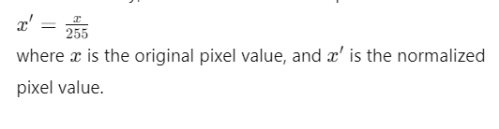

**Label Encoding:**

Labels were converted into numerical values corresponding to their respective classes. For a multi-class classification problem with three classes, one-hot encoding is used to represent each class as a binary vector.

The encoding is performed as follows:

* negative (0) -> [1, 0, 0]
* positive (1) -> [0, 1, 0]
* surprise (2) -> [0, 0, 1]

One-hot encoding ensures that the labels are in a format suitable for training a neural network.

#### 3.3 Model Architecture

A Convolutional Neural Network (CNN) was chosen for building the PTSD prediction model due to its proven effectiveness in image classification tasks. The architecture consists of several layers that work together to extract features from the input images and make predictions.

The CNN architecture includes the following layers:

1. **Convolutional Layer:** Applies filters to the input image to extract feature maps.
2. **ReLU Activation Function:** Introduces non-linearity by setting negative values to zero.
3. **Max Pooling Layer:** Reduces the spatial dimensions of the feature maps.
4. **Flatten Layer:** Converts the 2D feature maps into a 1D vector.
5. **Dense Layer:** Fully connected layer with neurons.
6. **Dropout Layer:** Regularization layer to prevent overfitting.
7. **Output Layer:** Produces the final class probabilities using softmax activation.

**Convolutional Layers:**

Convolutional layers apply a set of learnable filters to the input image, producing feature maps. The operation of convolution involves sliding the filters over the input image and computing the dot product between the filter and the receptive field.

Mathematically, the convolution operation is defined as:

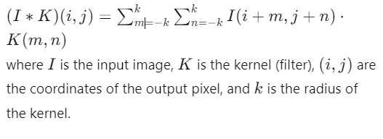

The first convolutional layer applies 32 filters of size 3x3 to the input image, while the second convolutional layer applies 64 filters of size 3x3 to the feature maps produced by the first layer.

**ReLU Activation Function:**

The Rectified Linear Unit (ReLU) activation function introduces non-linearity into the model by setting all negative values to zero. The ReLU function is defined as:



This non-linear transformation allows the model to learn complex patterns in the data.

**Max Pooling Layers:**

Max pooling layers reduce the spatial dimensions of the feature maps, thereby reducing the computational complexity and the risk of overfitting. Max pooling operates by selecting the maximum value within a sliding window.

For a 2x2 max pooling operation, the output is given by:

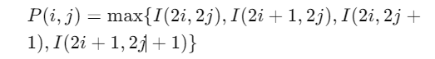

**Flatten Layer:**

The flatten layer converts the 2D feature maps into a 1D vector by unrolling the rows. This step prepares the data for the fully connected dense layers.



**Dense Layers:**

Dense layers are fully connected layers where each neuron is connected to every neuron in the previous layer. The dense layer performs a weighted sum of the inputs, followed by an activation function.

Mathematically, a dense layer can be expressed as:

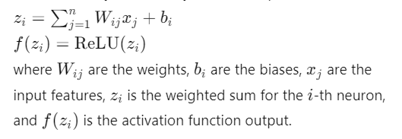

The first dense layer contains 128 units with ReLU activation, while the output layer contains units equal to the number of classes (3) with softmax activation.

**Dropout Layer:**

The dropout layer is a regularization technique used to prevent overfitting. During training, a fraction ppp of the input units is set to zero, forcing the network to learn more robust features.

The mathematical expression for dropout is:

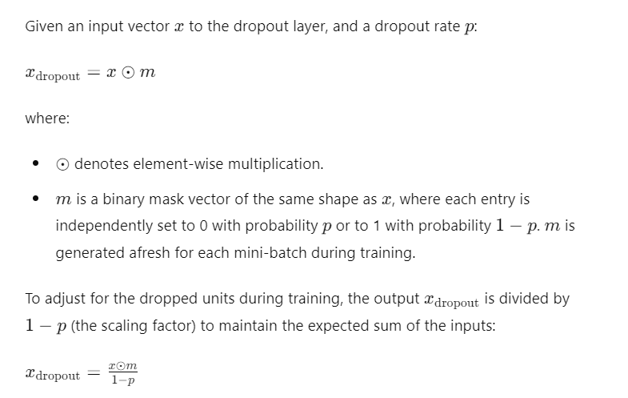

### 3.4 Training Process

The model training process involved several key steps:

1. **Data Splitting:**
   * The dataset was divided into training and validation sets using an 80-20 split. This ensured that the model's performance could be evaluated on unseen data, assessing its generalization capability.
2. **Model Training:**
   * The model underwent training for 10 epochs with a batch size of 32. An epoch represents a complete pass through the entire training dataset. The chosen batch size determined the number of samples processed before updating the model's parameters.
   * The training employed the categorical crossentropy loss function and the Adam optimization algorithm.

**Loss Function (Categorical Crossentropy):** 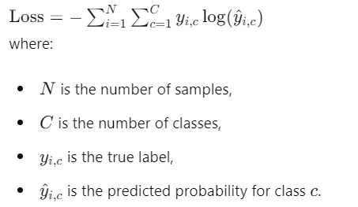

**Optimization Algorithm (Adam):**

* + Adam optimizer combines the benefits of AdaGrad and RMSProp algorithms to minimize the loss function.

1. **Saving the Model:**
   * The trained model was saved for future use, ensuring that the exact state of the model could be retrieved for further evaluation or deployment.

### 3.5 Evaluation Metrics

The model's performance was assessed using the following metrics:

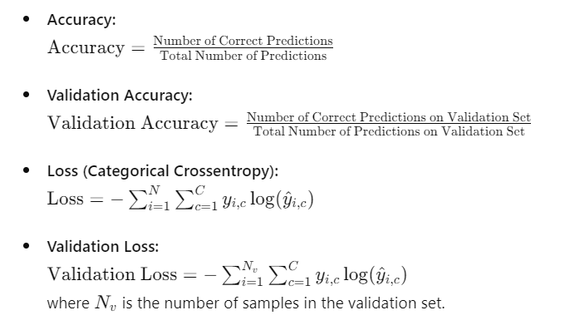

* **Confusion Matrix:**
  + The confusion matrix provided a detailed breakdown of correct and incorrect predictions for each class, enabling further metrics such as precision, recall, and F1-score to be calculated.

From the confusion matrix, additional metrics such as precision, recall, and F1-score can be calculated:

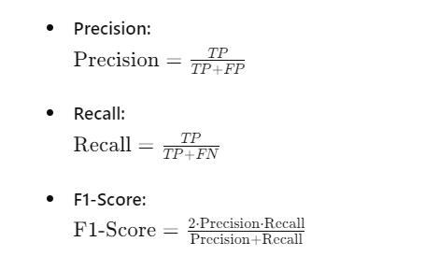

These metrics provided a comprehensive evaluation of the model's performance, ensuring robustness and reliability in its predictions.

**System Requirements:**

* **Operating System:** Ubuntu 18.04
* **Hardware:** 32GB RAM, Dual-core processor, 1TB storage

**Software Requirements:**

* **Languages:** Python 3.9
* **Frameworks/Libraries:** Streamlit, TensorFlow ,Pillow.Sci-kit learn, Numpy
* **Development Tools:** VS Code, Git,
* **Deployment:** Streamlit cloud

Chapter 4: Results and Discussion

This chapter presents the results of the PTSD prediction model and discusses its performance. It includes details on the model training process, evaluation metrics, and visual evidence of the app's functionality through screenshots.



#### 4.1 Model Training

The PTSD prediction model was trained using a Convolutional Neural Network (CNN) with a dataset containing images categorized into three classes: negative, positive, and surprise. The final training epoch (Epoch 10/10) achieved the following metrics:

* **Accuracy:** 0.9980
* **Validation Accuracy:** 0.9988
* **Loss:** 0.0128
* **Validation Loss:** 0.0027

These metrics indicate that the model performed exceptionally well on both the training and validation datasets, achieving near-perfect accuracy.

#### 4.2 Evaluation Metrics

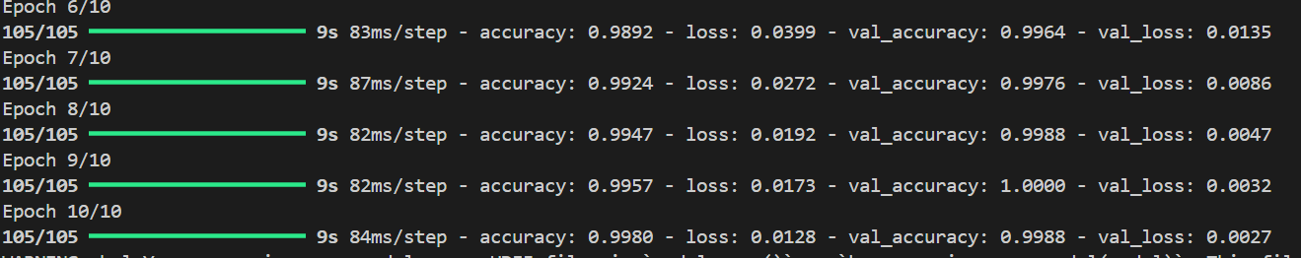

The performance of the model was evaluated using the following metrics:

* **Accuracy:** This metric measures the proportion of correctly predicted instances among the total instances. An accuracy of 0.9980 indicates that the model correctly predicted 99.80% of the instances in the training set.
* **Validation Accuracy:** Similar to accuracy, this metric measures the proportion of correctly predicted instances in the validation set. The validation accuracy of 0.9988 shows that the model maintained high performance on unseen data.
* **Loss:** The loss function measures the difference between the predicted values and the actual values. A lower loss value indicates better model performance. The training loss was 0.0128.
* **Validation Loss:** This metric evaluates the model's performance on the validation set. The validation loss of 0.0027 indicates that the model generalizes well to new data.

#### 4.3 Model Performance

The high accuracy and low loss values demonstrate that the model effectively distinguishes between the three classes of images. The following confusion matrix provides a detailed view of the model's performance:

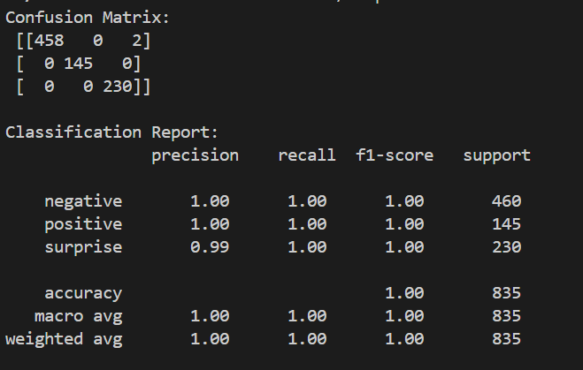

The classification report includes precision, recall, and F1-score for each class, providing a comprehensive evaluation of the model's performance.

#### 4.4 Application Functionality

The PTSD prediction model was integrated into a Streamlit app, allowing users to upload images and receive predictions in real-time. The following screenshots demonstrate the functionality of the app:

**Figure 4.1: App Interface for Image Upload**

Description: The screenshot shows the app interface where users can upload BMP images for prediction.

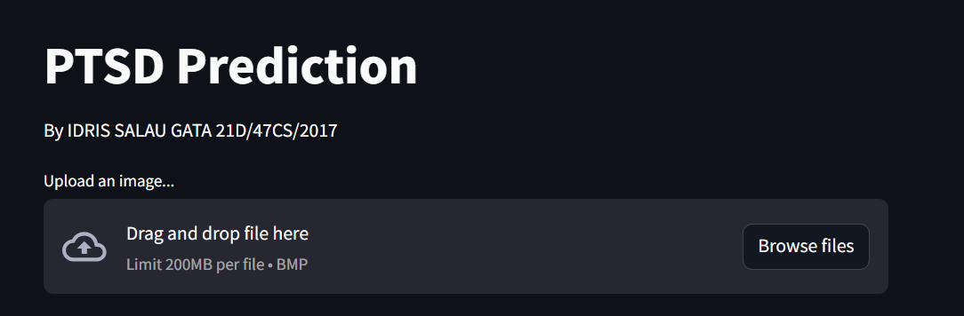

**Figure 4.2: Prediction Result**



Description: The screenshot displays the prediction result for an uploaded image, indicating the predicted class (negative, positive, or surprise).

#### 4.5 Discussion

The results obtained from the model training and evaluation indicate that the CNN-based PTSD prediction model is highly accurate and generalizes well to new data. The near-perfect accuracy and low loss values demonstrate the model's robustness. The integration with a Streamlit app provides an easy-to-use interface for users, making it accessible for practical use.

Future work may involve expanding the dataset, experimenting with different model architectures, and further refining the app's user interface to enhance user experience.

REFERENCES:

1. Bertl, M., Metsallik, J., & Ross, P. (2022). A systematic literature review of AI-based digital decision support systems for post-traumatic stress disorder. *Frontiers in Psychiatry*, *13*. <https://doi.org/10.3389/fpsyt.2022.923613>
2. Iyortsuun, N. K., Kim, S.-H., Jhon, M., Yang, H.-J., & Pant, S. (2023). A Review of Machine Learning and Deep Learning Approaches on Mental Health Diagnosis. *Healthcare*, *11*(3), Article 3. https://doi.org/10.3390/healthcare11030285
3. Bickman, L. (2020). Improving Mental Health Services: A 50-Year Journey from Randomized Experiments to Artificial Intelligence and Precision Mental Health. *Administration and Policy in Mental Health and Mental Health Services Research*, *47*(5), 795–843. https://doi.org/10.1007/s10488-020-01065-8
4. Boucher, E. M., Harake, N. R., Ward, H. E., Stoeckl, S. E., Vargas, J., Minkel, J., Parks, A. C., & Zilca, R. (2021). Artificially intelligent chatbots in digital mental health interventions: A review. *Expert Review of Medical Devices*, *18*(sup1), 37–49. https://doi.org/10.1080/17434440.2021.2013200
5. Ćosić, K., Popović, S., Šarlija, M., Kesedžić, I., & Jovanovic, T. (2020). Artificial intelligence in prediction of mental health disorders induced by the COVID-19 pandemic among health care workers. *Croatian Medical Journal*, *61*(3), 279–288. https://doi.org/10.3325/cmj.2020.61.279
6. Denecke, K., & Reichenpfader, D. (2023). Sentiment analysis of clinical narratives: A scoping review. *Journal of Biomedical Informatics*, *140*, 104336. https://doi.org/10.1016/j.jbi.2023.104336
7. Dutheil, F., Mondillon, L., & Navel, V. (2021). PTSD as the second tsunami of the SARS-Cov-2 pandemic. *Psychological Medicine*, *51*(10), 1773–1774. https://doi.org/10.1017/S0033291720001336
8. Iyortsuun, N. K., Kim, S.-H., Jhon, M., Yang, H.-J., & Pant, S. (2023). A Review of Machine Learning and Deep Learning Approaches on Mental Health Diagnosis. *Healthcare*, *11*(3), Article 3. https://doi.org/10.3390/healthcare11030285
9. Johnson, S. U., Ebrahimi, O. V., & Hoffart, A. (2020). PTSD symptoms among health workers and public service providers during the COVID-19 outbreak. *PLOS ONE*, *15*(10), e0241032. https://doi.org/10.1371/journal.pone.0241032
10. Kasban, H., El-Bendary, M. A. M., & Salama, D. H. (2015). *A Comparative Study of Medical Imaging Techniques*.
11. Krediet, E., Bostoen, T., Breeksema, J., van Schagen, A., Passie, T., & Vermetten, E. (2020). Reviewing the Potential of Psychedelics for the Treatment of PTSD. *International Journal of Neuropsychopharmacology*, *23*(6), 385–400. https://doi.org/10.1093/ijnp/pyaa018
12. Lekkas, D., & Jacobson, N. C. (2021). Using artificial intelligence and longitudinal location data to differentiate persons who develop posttraumatic stress disorder following childhood trauma. *Scientific Reports*, *11*(1), 10303. https://doi.org/10.1038/s41598-021-89768-2
13. Martin, A., Naunton, M., Kosari, S., Peterson, G., Thomas, J., & Christenson, J. K. (2021). Treatment Guidelines for PTSD: A Systematic Review. *Journal of Clinical Medicine*, *10*(18), Article 18. https://doi.org/10.3390/jcm10184175
14. Olawade, D. B., Wada, O. Z., Odetayo, A., David-Olawade, A. C., Asaolu, F., & Eberhardt, J. (2024). Enhancing mental health with Artificial Intelligence: Current trends and future prospects. *Journal of Medicine, Surgery, and Public Health*, *3*, 100099. https://doi.org/10.1016/j.glmedi.2024.100099
15. Patil, M. K., Chaudhari, N., Bhavsar, R., & Pawar, B. (2020). A review on sentiment analysis in psychomedical diagnosis. *Open Journal of Psychiatry & Allied Sciences*, *11*(2), 80. https://doi.org/10.5958/2394-2061.2020.00025.7
16. Pham, K. T., Nabizadeh, A., & Selek, S. (2022). Artificial Intelligence and Chatbots in Psychiatry. *Psychiatric Quarterly*, *93*(1), 249–253. https://doi.org/10.1007/s11126-022-09973-8
17. Rumball, F., Happé, F., & Grey, N. (2020). Experience of Trauma and PTSD Symptoms in Autistic Adults: Risk of PTSD Development Following DSM-5 and Non-DSM-5 Traumatic Life Events. *Autism Research*, *13*(12), 2122–2132. https://doi.org/10.1002/aur.2306
18. Sadeghi, M., McDonald, A. D., & Sasangohar, F. (2022). Posttraumatic stress disorder hyperarousal event detection using smartwatch physiological and activity data. *PLOS ONE*, *17*(5), e0267749. https://doi.org/10.1371/journal.pone.0267749
19. Sawalha, J., Yousefnezhad, M., Shah, Z., Brown, M. R. G., Greenshaw, A. J., & Greiner, R. (2022). Detecting Presence of PTSD Using Sentiment Analysis From Text Data. *Frontiers in Psychiatry*, *12*. https://doi.org/10.3389/fpsyt.2021.811392
20. Sharifani, K., & Amini, M. (2023). *Machine Learning and Deep Learning: A Review of Methods and Applications* (SSRN Scholarly Paper 4458723). https://papers.ssrn.com/abstract=4458723
21. Sheynin, S., Wolf, L., Ben-Zion, Z., Sheynin, J., Reznik, S., Keynan, J. N., Admon, R., Shalev, A., Hendler, T., & Liberzon, I. (2021). Deep learning model of fMRI connectivity predicts PTSD symptom trajectories in recent trauma survivors. *NeuroImage*, *238*, 118242. https://doi.org/10.1016/j.neuroimage.2021.118242
22. Wu, Y., Mao, K., Dennett, L., Zhang, Y., & Chen, J. (2023). Systematic review of machine learning in PTSD studies for automated diagnosis evaluation. *Npj Mental Health Research*, *2*(1), 1–10. https://doi.org/10.1038/s44184-023-00035-w
23. Zunic, A., Corcoran, P., & Spasic, I. (2020). Sentiment Analysis in Health and Well-Being: Systematic Review. *JMIR Medical Informatics*, *8*(1), e16023. <https://doi.org/10.2196/16023>

**APPENDIX**

# streamlit_app.py

import streamlit as st

from tensorflow.keras.preprocessing.image import ImageDataGenerator

from tensorflow.keras.models import Sequential

from tensorflow.keras.layers import Conv2D, MaxPooling2D, Flatten, Dense, Dropout

from tensorflow.keras.utils import to_categorical

from sklearn.model_selection import train_test_split

from sklearn.metrics import confusion_matrix, classification_report

import numpy as np

from PIL import Image

import os

# Define paths

DATA_DIR = 'dataset'

CATEGORIES = ['negative', 'positive', 'surprise']

# Function to load and preprocess images

def load_images(data_dir, categories, img_size=(64, 64)):

    data = []

    labels = []

    for category in categories:

        path = os.path.join(data_dir, category)

        class_num = categories.index(category)

        for img_name in os.listdir(path):

            try:

                img_path = os.path.join(path, img_name)

                image = Image.open(img_path).convert('RGB')

                image = image.resize(img_size)

                image = np.array(image)

                data.append(image)

                labels.append(class_num)

            except Exception as e:

                pass

    data = np.array(data) / 255.0

    labels = np.array(labels)

    return data, labels

# Load and preprocess data

data, labels = load_images(DATA_DIR, CATEGORIES)

labels = to_categorical(labels, num_classes=len(CATEGORIES))

X_train, X_test, y_train, y_test = train_test_split(data, labels, test_size=0.2, random_state=42)

# Define the CNN model

def create_model():

    model = Sequential([

        Conv2D(32, (3, 3), activation='relu', input_shape=(64, 64, 3)),

        MaxPooling2D(pool_size=(2, 2)),

        Conv2D(64, (3, 3), activation='relu'),

        MaxPooling2D(pool_size=(2, 2)),

        Flatten(),

        Dense(128, activation='relu'),

        Dropout(0.5),

        Dense(len(CATEGORIES), activation='softmax')

    ])

    model.compile(optimizer='adam', loss='categorical_crossentropy', metrics=['accuracy'])

    return model

# Train the model

model = create_model()

model.fit(X_train, y_train, epochs=10, validation_data=(X_test, y_test))

# Save the model

model.save('ptsd_cnn_model1.h5')

y_pred = model.predict(X_test)

y_pred_classes = np.argmax(y_pred, axis=1)

y_true = np.argmax(y_test, axis=1)

conf_matrix = confusion_matrix(y_true, y_pred_classes)

class_report = classification_report(y_true, y_pred_classes, target_names=CATEGORIES)

print("Confusion Matrix:\n", conf_matrix)

print("\nClassification Report:\n", class_report)

# Streamlit app

st.title('PTSD Prediction App')

uploaded_file = st.file_uploader('Upload an image...', type=['bmp'])

if uploaded_file is not None:

    image = Image.open(uploaded_file)

    st.image(image, caption='Uploaded Image.', use_column_width=True)

    image = image.convert('RGB')

    image = image.resize((64, 64))

    image = np.array(image) / 255.0

    image = np.expand_dims(image, axis=0)

    model = create_model()

    model.load_weights('ptsd_cnn_model.h5')

    prediction = model.predict(image)

    class_idx = np.argmax(prediction, axis=1)[0]

    class_name = CATEGORIES[class_idx]

    st.write(f'Prediction: {class_name}')

WEBAPP

# streamlit_app.py

import streamlit as st

from tensorflow.keras.preprocessing.image import ImageDataGenerator

from tensorflow.keras.models import Sequential

from tensorflow.keras.layers import Conv2D, MaxPooling2D, Flatten, Dense, Dropout

from tensorflow.keras.utils import to_categorical

from sklearn.model_selection import train_test_split

import numpy as np

from PIL import Image

import os

CATEGORIES = ['negative', 'positive', 'surprise']

def create_model():

    model = Sequential([

        Conv2D(32, (3, 3), activation='relu', input_shape=(64, 64, 3)),

        MaxPooling2D(pool_size=(2, 2)),

        Conv2D(64, (3, 3), activation='relu'),

        MaxPooling2D(pool_size=(2, 2)),

        Flatten(),

        Dense(128, activation='relu'),

        Dropout(0.5),

        Dense(len(CATEGORIES), activation='softmax')

    ])

    model.compile(optimizer='adam', loss='categorical_crossentropy', metrics=['accuracy'])

    return model

st.title('PTSD Prediction')

st.write('By IDRIS SALAU GATA 21D/47CS/2017')

uploaded_file = st.file_uploader('Upload an image...', type=['bmp'])

if uploaded_file is not None:

    image = Image.open(uploaded_file)

    st.image(image, caption='Uploaded Image.', use_column_width=True)

    image = image.convert('RGB')

    image = image.resize((64, 64))

    image = np.array(image) / 255.0

    image = np.expand_dims(image, axis=0)

    model = create_model()

    model.load_weights('ptsd_cnn_model.h5')

    prediction = model.predict(image)

    class_idx = np.argmax(prediction, axis=1)[0]

    class_name = CATEGORIES[class_idx]

    st.write(f'Prediction: {class_name}')